- THE ORGANIZATIONAL RESPONSE TO DIGITAL
DIGITAL TO EXECUTIVES
there are a lot of executives who need to understand the impact of digital better,but some of an organization’s inability to define and execute an effective digital strategy stems from the digital worker’s lack of basic management skills.
DIGITAL LEADERSHIP
“legacy” leadership needs to step aside and let the digital experts run the whole show. (kepemimpinan legacy perlu memberi jalan masuk digital experts utk menjalankan organisasi).
DIGITAL TEAM
Because digital teams are often led by managers who don’t understand how digital works,
digital resources may not have been developed as well as their counterparts in pure marketing or IT roles.
And it is these skills that are required in order to mature and integrate digital with the rest of the business.
Digital experts
senior leaders and digital experts
sitting in the same room having a serious conversation
about how to get digital done in their organization.
Hopefully,
while the conversation is happening, some knowledge and skill transfer can take place.
DO/DOES:
Make sure that your digital strategy is articulated via both quantitative and qualitative factors.
--------------------------------------------------------------------------------------------------------------------------------------
- DIGITAL STRATEGY
(Who Should Define Digital Strategy?)
- The right set of resources: 3P

  - People who know how to analyze and evaluate the impact of digital in your markets.
  - People who have the knowledge and ability to conceive an informed and visionary response to that impact.
  - People who have the business expertise and authority to ensure that the digital vision is effectively implemented.

- THE ROLE OF LEADERSHIP
A good leader should manage the following areas:
- Make sure that the digital strategy is informed by non-digital strategic business objectives.
- Ensure that the digital presence performs for the organization by pressing for and contributing to the definition of measureable outcomes.
- Provide market analysis and expertise, ensuring that the digital strategy is “worth the effort.”
- Align management for implementation of the digital strategy.

- THE ROLE OF THE DIGITAL WORKER.
The digital worker/user experience role should perform as follows:
  - Brainstorm and invent.
digital functionality in order to meet business goals.
  - Ensure that the digital presence
aligns with good practices and relevant emerging trends in digital
  - Provide digital expertise and experience ensuring that
the digital strategy is “doable.”
  - Ensure that the digital and non-digital experiences of the customer/user
make sense and produce value for the business.
  - Align
organizational digital workers for implementation of the digital strategy

DIGITAL STRATEGY INPUTS

1. Leadership Focus
- Executives
- Analysts
- Lines of Business Leads and “Product Managers”

2. Digital Focus
- User Experience
- Senior Digitalists
- Content
- Technology

DON’T confuse your organizational digital strategy with your content, technology, or user experience strategies.
--------------------------------------------------------------------------------------------------------------------------------------

- DIGITAL STRATEGY
(DO YOU REALLY NEED A SEPARATE DIGITAL STRATEGY?)
DIGITAL STRATEGY
- DICO: digital is the product or service (think Amazon or Netflix)
  - Competition and the market have forced your organization to address digital strategy head-on.
  - The one whose role it is to define the strategy—most likely a diverse team that includes senior digital subject matter experts and business experts
  - the organization has blended the legacy business strategy and operations with digital efforts so that everything works in concert.
- SUBTLY DISRUPTED : organizations that have more subtly or ambiguously been disrupted by digital (ice cream, thermometer, pharmaceutical)
  - digital strategy when you are not forced to do so in order to remain viable or if the impact is more subtle;
  - digital coming, but exactly how it’s going to impact your marketspace;
  - most of online happens behind firewall on intranet;
  - the integration of digital and “analog” business processes needs to happen, but in some cases that integration can be managed more gently.
DO’S : Make sure that business experts and digital experts inform your digital strategy. Alone, neither of these resource types has enough knowledge to get the job done well.

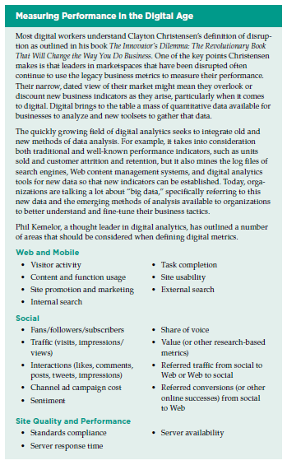
--------------------------------------------------------------------------------------------------------------------------------------
4. DIGITAL CONSERVATIVE & DIGITAL PROGRESSIVES
(Is Your Leader a Digital Conservative or a Digital Progress)
Digital Conservatives
- Digital conservatives are slower to leverage the capabilities of digital to augment existing or invent new business processes, products, and services.
- being aggressive or innovative around digital is not of strategic importance
- DON’T:
  - Expect digitally conservative leaders to eagerly adopt new technologies. Learn how to use metrics and more traditional business jargon to engage them in digital initiatives.
- THE UNINTENTIONAL DIGITAL CONSERVATIVE characteristics
The unintentional digital conservative often has the following characteristics:
  - Delegates digital strategy to more junior resources due to lack of interest.
  - Feels threatened by digital
  - Uses traditional pre-Web business metrics and tactics to evaluate and drive their business.
  - Is often unfamiliar with the strategic capabilities of digital.
- THE INTENTIONAL DIGITAL CONSERVATIVE characteristics:
  - Purposely delegates digital strategy to more junior resources.
  - Monitors how digital is impacting the organization.
  - Incorporates new ways of measuring business effectiveness.
  - Understands the strategic capabilities of digital and how it might be leveraged in the organization’s market.
DIGITAL PROGRESSIVES
- Digital progressives are faster to leverage the capabilities of digital to augment existing or invent new business processes, products, and services.
- They might be leveraging “big data” to better understand the behaviors and needs of their customer base and to shape and drive the operations of the business.
- And you can also see the digital progressive that leans into digital indiscriminately.
THE UNINTENTIONAL DIGITAL PROGRESSIVE characteristics:
- Implements digital capabilities without real business case or performance objectives.
- Sometimes indiscriminately adopts new technologies without any real business purpose.
THE INTENTIONAL DIGITAL PROGRESSIVE characteristics:
- Integrates digital strategy with overall business strategy
- Utilizes digital capabilities to invent new ways to do business and to set norms for others in their marketspace.
- Tunes operational and governance practices to support the new normal of digital.

