MANAGING SOCIAL RESPONSIBILITY AND ATHICS-I
A NOVEL WELLNESS CULTURE
ROBBINS 13TH EDITION P-209
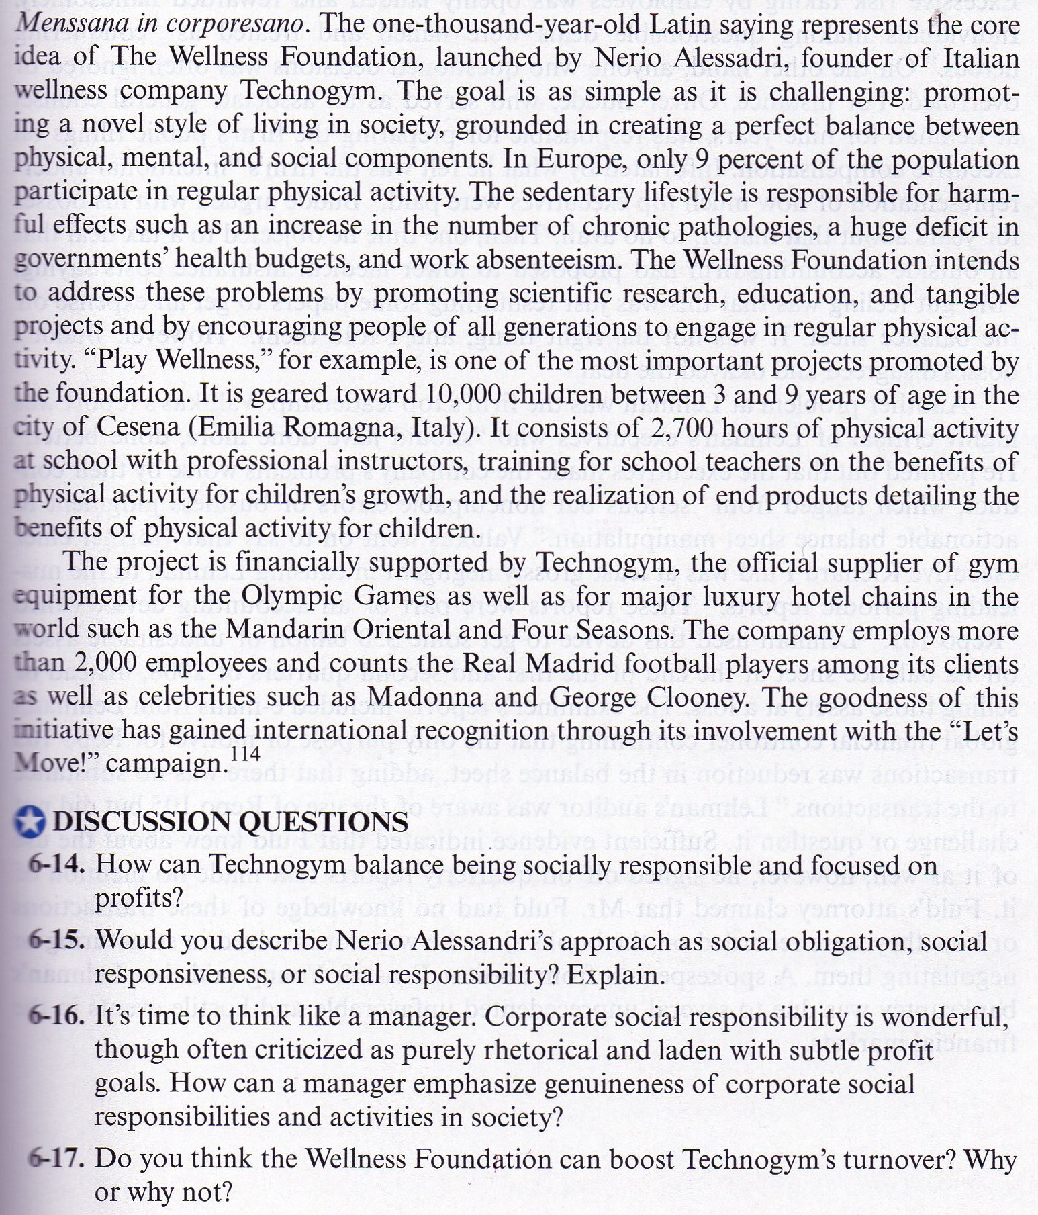

MANAGING SOCIAL RESPONSIBILITY AND ATHICS -II
LESSON FROM LEHMAN BROTHERS: WILL WE EVER LEARN
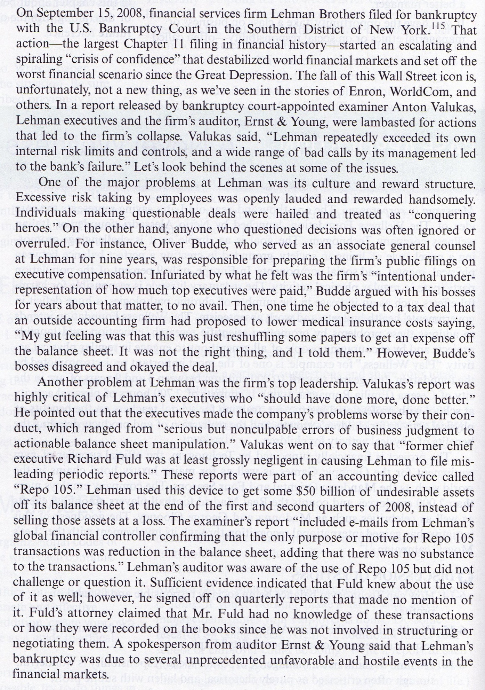
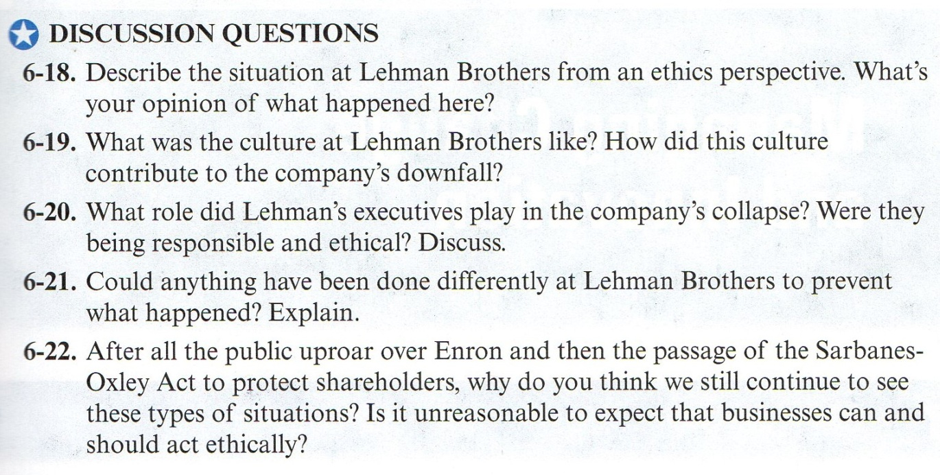

MANAGING IN GLOBAL ENVIRONMENT- I
DIRTY LITTLE SECRET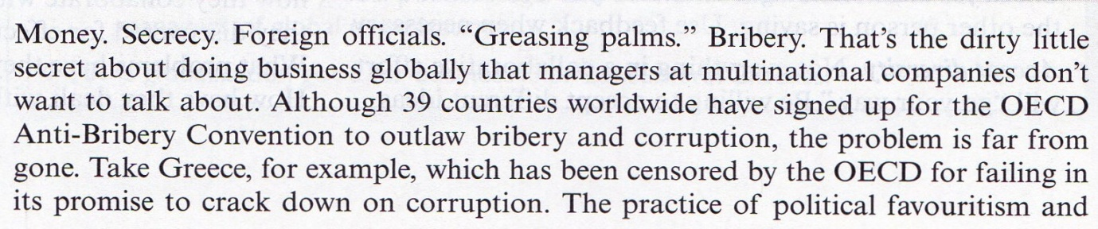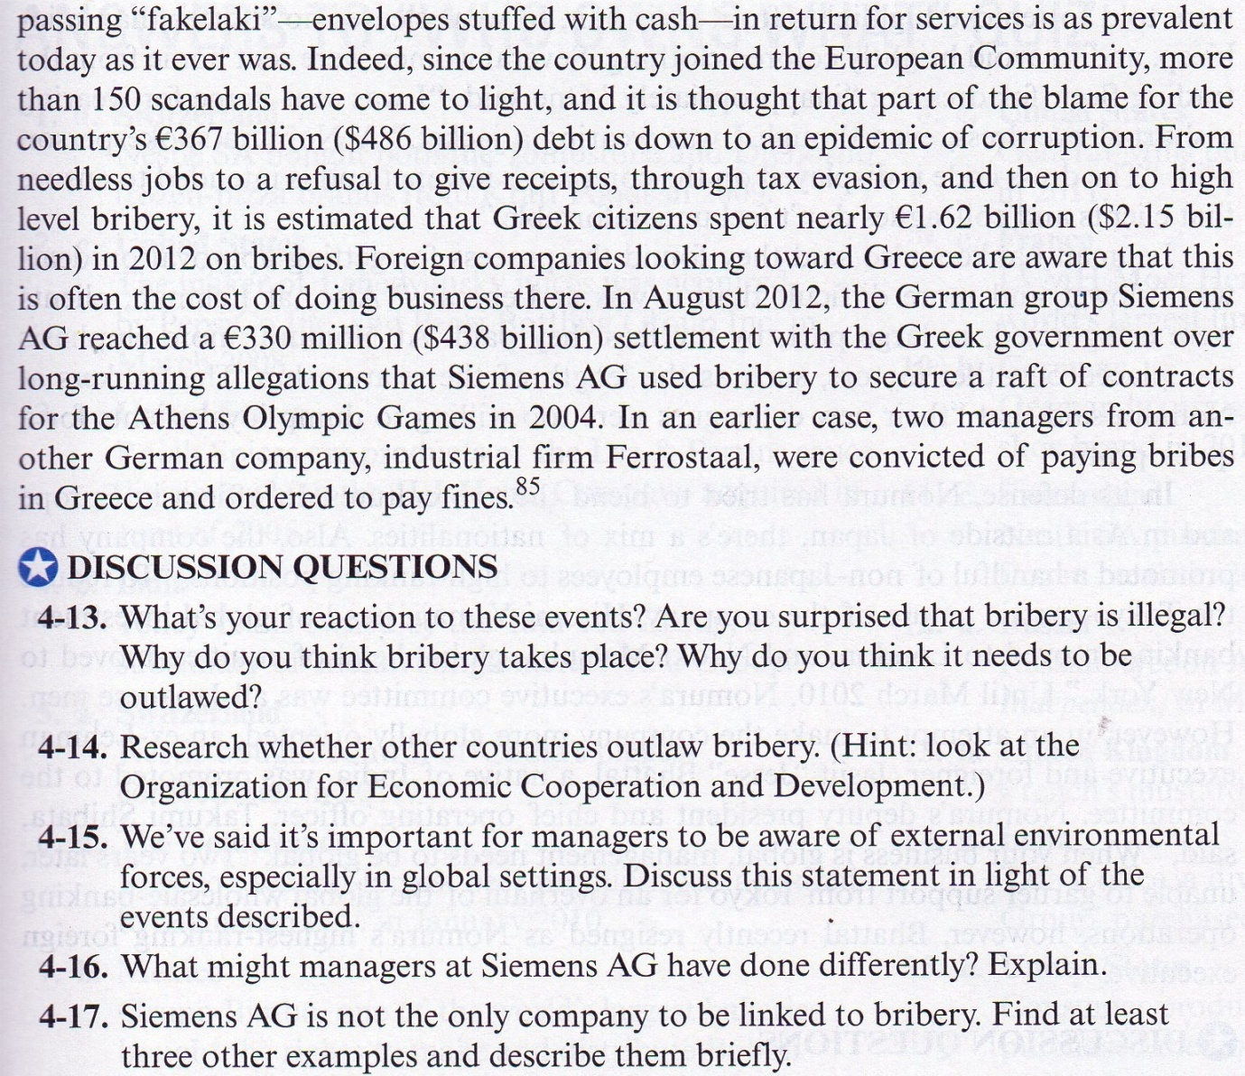

MANAGING IN GLOBAL ENVIRONMENT -I
GLOBAL STUMBLE 